- SSUSH16 The student will identify key developments in the aftermath of WW I.

- Rise of ____________________________

- The number of ________________ Unions rose during WW I
- Unions began using strikes as a means of trying to gain better _________________ conditions
- __________________ were associated with Communist led protests in Europe and worried many Americans that ________________________ would spread to the U.S.
- -350,000 ________________ workers went on strike in 1919.
- -The head of _____________. Steel blamed the unrest on foreign radicals and broke the strike by hiring ______________ Americans and __________________ to work.

- The Red _________________

- -Numerous strikes in 1919 led many Americans to believe that the Communists were trying to start a ____________________ in the U.S.
- -The Communists were blamed for sending ______________ through the ________________ system as a way of disrupting the American way of life
- -As a way of limiting “_______________” Congress passed laws limiting foreign ________________ to the U.S.
- Definition: Red Scare: The ______________ that _____________________ was making its way into the United States through government ______________, Hollywood actors, and ________________ employees.

- The Red Scare: _________________
- Senator Joseph McCarthy
  - __________________ of communist sympathizers in US Gov’t
  - Spends 5 years on a communist “__________________ hunt.”
  - His __________________ were so strong that few spoke out _____________ him
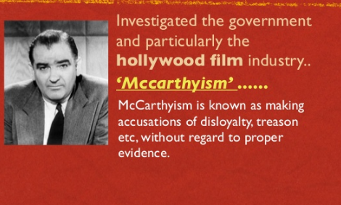

- “Red” and communism today
- During and after the Red Scare, the color ______________ is often associated with communist countries.

- Changes in the early 1900s
- Red Scare
- ______________ and television
- Continued growth in ____________
  - Henry _____________
    - _____________ Line
    - Model T
- ____________ American interest in the ______________
  - __________________ Renaissance

- Henry Ford
- 1n 1908 Henry Ford began to _______________ produce cars, automobiles that the “everyday” man could ___________________.
- He paid his workers ______________ a day and sold his original Model “T” for ______________.
- Ford used the idea of mass production to build his cars on an _______________ line.
- Each worker had a _____________ job to do, which helped speed up the building process, reducing the cost of ______________________.
- The automobile changed how Americans ______________, allowing them to ____________________ greater distances much quicker
The automobile industry also created growth in other industries such as the _______________, glass, and lead industries.

- Impact of the _____________
- Radio companies such as _______________ and _______________ were formed in the 1920s.
- Radio allowed listeners to ___________ instant news of events and was a way for families to come together to listen to _________________.
- Movies in the 1920s helped show “_______________” lifestyles to Americans

Music and Cultural Expression
- Louis ______________
- -Born in New Orleans and moved to Chicago in his 20s
- -Played the cornet and ______________ and ____________ an improvised form of Dixie Ragtime and jazz
- -Influential in the New York jazz scene
  - Ain’t Misbehavin’
Langston Hughes
- -Born in ______________
- -Wrote _________________ describing the _________________ of many African Americans

- _______________ Pan Alley
- Tin Pan Alley was the name given to _____________ York City’s ______________ and music publishers during the 1920s _
- One of the most famous writers was ________________ Berlin, who wrote such songs as “God Bless America”, “______________ Christmas”, and “Alexander’s Ragtime Band”

